**Web Programming**

Lab - 14

React

Name: Sushen Grover

Reg No: 23BCE1728

Slot: L11+L12+L31+L32

Class No: CH2024250502774

Course Code: BCSE203E

Faculty: Dr. L.M. Jenila Livingston

Question:

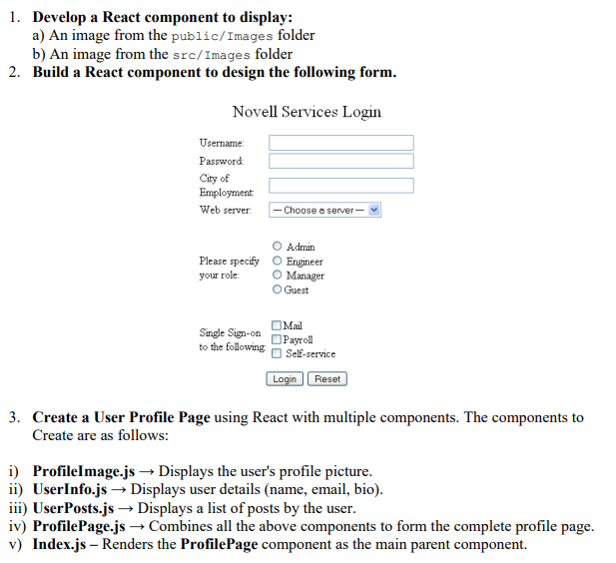

Code:

**App.js**

import React from "react";

import { DisplayImages, UserForm, ProfilePage } from "./ProfileComponents";

function App() {

  return (

    <div>

      <h1>Part 1</h1>

      <DisplayImages />

      <h1>Part 2</h1>

      <UserForm />

      <h1>Part 3</h1>

      <ProfilePage />

    </div>

  );

}

export default App;

**Index.js**

import React from 'react';

import ReactDOM from 'react-dom/client';

import './index.css';

import App from './App';

import reportWebVitals from './reportWebVitals';

const root = ReactDOM.createRoot(document.getElementById('root'));

root.render(

  <React.StrictMode>

    <App />

  </React.StrictMode>

);

// If you want to start measuring performance in your app, pass a function

// to log results (for example: reportWebVitals(console.log))

// or send to an analytics endpoint. Learn more: https://bit.ly/CRA-vitals

reportWebVitals();

**ProfileComponents.js**

import React from "react";

// 1. Display images from different folders

const DisplayImages = () => {

  return (

    <div>

      <h2>Images from Different Folders</h2>

      <img

        src={process.env.PUBLIC_URL + "/Images/public-image.jpg"}

        alt="Public Folder"

        width="200"

      />

      <br />

      <img

        src={require("./Images/src-image.jpg")}

        alt="Src Folder"

        width="200"

      />

    </div>

  );

};

// 2. Form Component

const UserForm = () => {

    return (

        <div style={{ width: '300px', margin: '0 auto', fontFamily: 'Arial, sans-serif' }}>

          <h2 style={{ textAlign: 'center' }}>Novell Services Login</h2>

          <form>

            {/* Username */}

            <label htmlFor="username">Username:</label>

            <br />

            <input type="text" id="username" name="username" style={{ width: '100%' }} />

            <br /><br />

            {/* Password */}

            <label htmlFor="password">Password:</label>

            <br />

            <input type="password" id="password" name="password" style={{ width: '100%' }} />

            <br /><br />

            {/* City of Employment */}

            <label htmlFor="city">City of Employment:</label>

            <br />

            <input type="text" id="city" name="city" style={{ width: '100%' }} />

            <br /><br />

            {/* Web Server */}

            <label htmlFor="server">Web server:</label>

            <br />

            <select id="server" name="server" style={{ width: '100%' }}>

              <option value="">-- Choose a server --</option>

              {/* Add more options as needed */}

            </select>

            <br /><br />

            {/* Role Selection */}

            <p>Please specify your role:</p>

            <input type="radio" id="admin" name="role" value="Admin" />

            <label htmlFor="admin">Admin</label>

            <br />

            <input type="radio" id="engineer" name="role" value="Engineer" />

            <label htmlFor="engineer">Engineer</label>

            <br />

            <input type="radio" id="manager" name="role" value="Manager" />

            <label htmlFor="manager">Manager</label>

            <br />

            <input type="radio" id="guest" name="role" value="Guest" />

            <label htmlFor="guest">Guest</label>

            <br /><br />

            {/* Single Sign-on Options */}

            <p>Single Sign-on to the following:</p>

            <input type="checkbox" id="mail" name="ssoMail" value="Mail" />

            <label htmlFor="mail">Mail</label>

            <br />

            <input type="checkbox" id="payroll" name="ssoPayroll" value="Payroll" />

            <label htmlFor="payroll">Payroll</label>

            <br />

            <input type="checkbox" id="selfService" name="ssoSelfService" value="Self-service" />

            <label htmlFor="selfService">Self-service</label>

            <br /><br />

            {/* Buttons */}

            <div style={{ textAlign: 'center' }}>

              <button type="submit">Login</button>

              &nbsp;

              <button type="reset">Reset</button>

            </div>

          </form>

        </div>

      );

};

// 3. User Profile Page Components

const ProfileImage = () => {

  return (

    <img src={require("./Images/profile.jpg")} alt="Profile" width="150" />

  );

};

const UserInfo = ({ name, email, bio }) => {

  return (

    <div>

      <h2>{name}</h2>

      <p>Email: {email}</p>

      <p>Bio: {bio}</p>

    </div>

  );

};

const UserPosts = ({ posts }) => {

  return (

    <div>

      <h3>User Posts</h3>

      <ul>

        {posts.map((post, index) => (

          <li key={index}>{post}</li>

        ))}

      </ul>

    </div>

  );

};

const ProfilePage = () => {

  const user = {

    name: "Sushen Grover",

    email: "sushen.grover2023@vitstudent.ac.in",

    bio: "A passionate developer.",

    posts: ["First Post", "Second Post", "Third Post"],

  };

  return (

    <div>

      <ProfileImage />

      <UserInfo name={user.name} email={user.email} bio={user.bio} />

      <UserPosts posts={user.posts} />

    </div>

  );

};

export { DisplayImages, UserForm, ProfilePage };

**ProfileImage.js**

// ProfileImage.js

import React from "react";

const ProfileImage = () => {

  return (

    <img

      src={require("./Images/profile.jpg")}

      alt="Profile"

      width="150"

      style={{ borderRadius: "50%" }}

    />

  );

};

export default ProfileImage;

**ProfilePage.js**

// ProfilePage.js

import React from "react";

import ProfileImage from "./ProfileImage";

import UserInfo from "./UserInfo";

import UserPosts from "./UserPosts";

const ProfilePage = () => {

  const user = {

    name: "Sushen Grover",

    email: "sushen.grover2023@vitstudent.ac.in",

    bio: "A passionate developer.",

    posts: ["First Post", "Second Post", "Third Post"],

  };

  return (

    <div style={{ textAlign: "center", fontFamily: "Arial, sans-serif" }}>

      <ProfileImage />

      <UserInfo name={user.name} email={user.email} bio={user.bio} />

      <UserPosts posts={user.posts} />

    </div>

  );

};

export default ProfilePage;

**UserInfo.js**

// UserInfo.js

import React from "react";

const UserInfo = ({ name, email, bio }) => {

  return (

    <div>

      <h2>{name}</h2>

      <p>Email: {email}</p>

      <p>Bio: {bio}</p>

    </div>

  );

};

export default UserInfo;

**UserPosts.js**

// UserPosts.js

import React from "react";

const UserPosts = ({ posts }) => {

  return (

    <div>

      <h3>User Posts</h3>

      <ul>

        {posts.map((post, index) => (

          <li key={index}>{post}</li>

        ))}

      </ul>

    </div>

  );

};

export default UserPosts;

Output:

